**HKU SPACE Community College**

**Associate Degree Programme**

**2022 - 2023**

**Introduction to Database Systems (CL01)**

“Restaurant Ordering System”

Luqman Mohammad 20169763

Kafle Manis 20188059

YIP Cheuk Yui 20193212

1. Introduction

1.1 Business Background

The restaurant, Boka making Foods, is a fast casual takeaway restaurant that offers a variety of menu items, including various types of burgers, pizzas, and beverages. It allows customers to select self-chosen menu items as a set, with 2 bundles in total: "Set for 2" and "Set for 4". Within "Set for 2", the customer has the freedom to choose 2 burgers, 1 pizza, and 2 beverages of their choice, while in "Set for 4", they can choose up to 4 burgers, 2 pizzas, and 4 beverages. The business model focuses on generating revenue through sales from takeaway customers, with the added benefit of allowing customers to order self-chosen sets. The target customers are the general public, especially students and office workers, who are looking for convenient and affordable meal options on-the-go. The goal of Boka making Foods is to continue to provide delicious and satisfying meals to their customers while implementing a new database system that can manage orders more efficiently and improve the overall customer experience. With a renewed focus on customer satisfaction and efficiency, we believe that we can help this fast casual takeaway restaurant to grow and succeed in the competitive food industry.

1.2 User Requirements

The new database system for Boka making Foods must meet several key user requirements in order to effectively manage orders and improve the overall customer experience. First and foremost, the system should allow staff to manage orders efficiently. This means that the system should provide a user-friendly interface that allows staff to add, modify, and delete orders quickly and easily. The system should also allow the staff to manage the menu. This means that the system should allow staff to add, modify, and delete menu items, and should be able to display the menu in a clear and organized way. Additionally, the system should be user-friendly and easy for staff to navigate, with an intuitive interface that simplifies the order management process. To further improve the customer experience, the database system should also be able to track customer information and order history, allowing for personalized recommendations and promotions based on past orders. By meeting these user requirements, the new database system for Boka making Foods can help to streamline operations, reduce errors, and improve the overall efficiency and effectiveness of this fast casual takeaway restaurant.

1. Data Models

2.1 Assumptions and Limitations

The database system for Boka making Foods has some assumptions that must be considered when using the system. Firstly, the database assumes that the menu items offered by the restaurant are fixed and do not change frequently. If the menu changes frequently or seasonally, the database may need to be updated accordingly to reflect the new menu items. Secondly, the database assumes that the prices of menu items are fixed and do not change frequently. If the prices change frequently or seasonally, the database may need to be updated to reflect the new prices. Additionally, the database assumes that payment is handled separately from the ordering system, with customers paying in-person at the restaurant. This means that the database does not handle payment processing or integration with payment gateways. These assumptions should be taken into consideration when using the database system, and adjustments may need to be made to reflect changes in the menu or pricing.

Moreover, there are some limitations while using the system for Boka making Foods that should be taken into consideration. Firstly, if there is a rapid growth in customer volume the database may face limitations in terms of scalability. As the volume of data and traffic increases, the database may need to be optimized or migrated to a more powerful system to handle larger volumes of data and traffic. Secondly, incomplete or inaccurate data entered into the database can lead to errors in orders management, customers management and other aspects of the business. It is therefore important to ensure that accurate and complete data is entered into the system at all times. Finally, the database may face limitations in terms of the inability to order a single menu item. As the restaurant only offers self-chosen sets, customers may not be able to order individual items that are not included in the set menus. These limitations should be taken into consideration when using the database system, and adjustments may need to be made to optimize the system for the business needs.

2.2 Database Design

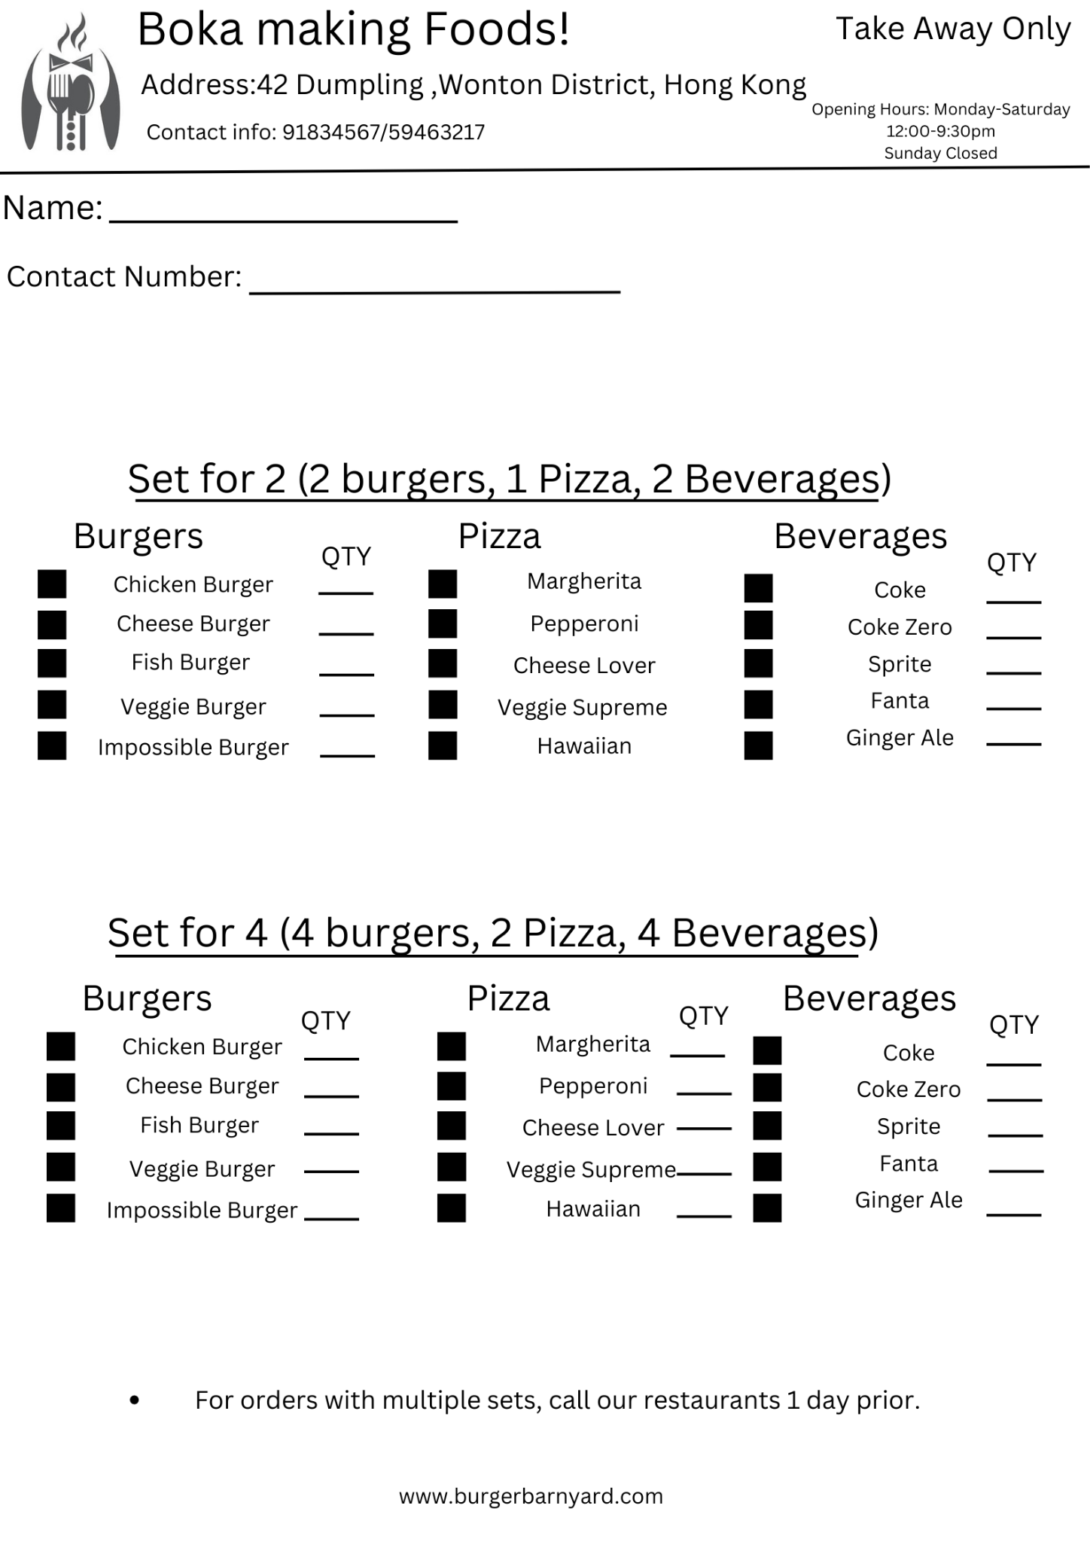

**Figure 1**

Figure 1 shows the order form for Boka making Food which shows the different types of orders menus available. It has 2 sections, 1 for “Set for 2” and another for “Set for 4”. The customer can choose the type of set they want and choose the items and quantities of certain order items that they choose. In the “Set for 2”, the customer can order 2 burgers, 1 pizza and 2 beverages and in “Set for 4” they can select up to 4 burgers, 2 pizzas and 4 beverages. For multiple sets, the customers need to call the restaurant 1 day prior to place their order.

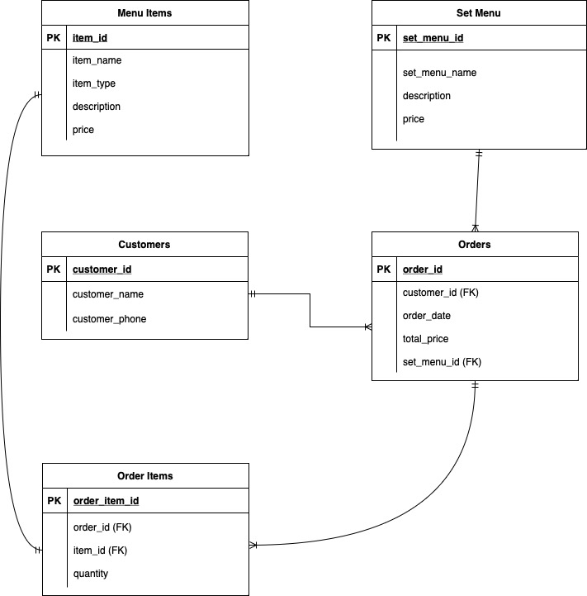

**Figure 2**

Figure 2 illustrates the ER diagram for our database which has 5 entities and clearly shows all attributes,the primary keys and foreign keys within each entity. The Customers table stores information about the customers and the Orders table stores information about the orders such as order id, order date and total price with a foreign key to the Customers table and Set Menu table. The customers table has a 1:M relationship with the Orders table as a single customer can place multiple orders. Orders table has a 1:M relationship with Order Items table because 1 order can have multiple order items such as 2 burgers or 4 burgers etc.

Order Items table stores the information about the items in each order and their quantity and has a foreign key to Orders table and Menu Items table. The Menu Items table has information about all the menu items with their name, type, description and price. The relationship between Order Items table and Menu Items table is 1:1 because 1 order item corresponds to 1 menu item.

Set menu name description and the price of the set is stored within the Set Menu table which has a 1:M relationship with the Orders table because certain types of set menus can be present in many orders.

1. System Design

3.1 Initial setup

Menu Items: Name, type, description and price of each food item

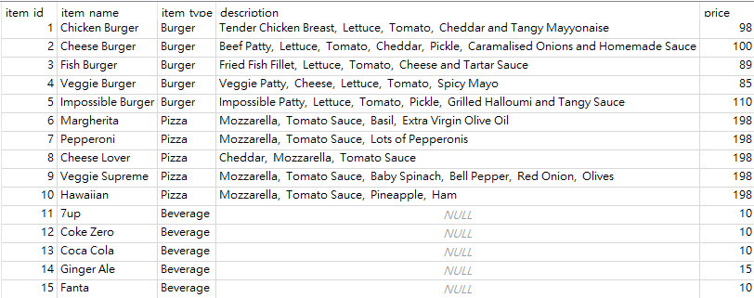

The Menu Items table stores information about every item appearing in the menu. Currently, there are three types of menu items: Burger, Pizza, and Beverage. Each item has its own name, description and price. In this table, the item_id is an automatically generated integer and is the primary key.

Set Menus: Name, description and price of each set menu



The Set Menus table stores all set menus that can be ordered in the system. Each set menu has its own price. Combinations of menu items, shown as numbers of burgers, pizzas and beverages, are stored as the description. The set_menu_id is the primary key of the table and is an automatically generated integer.

Customers: Name and phone number

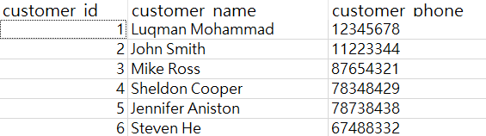

The Customers table stores the information of all customers who have used the ordering system at least once. Each customer has his/her own name and phone number. The customer_id is the primary key of this table and is automatically generated.

3.2 Data Management

The system receives new data entry when new orders are made. The Orders table and the Order Items table store information about these orders.

Orders: Customer, date of order, set menu and price

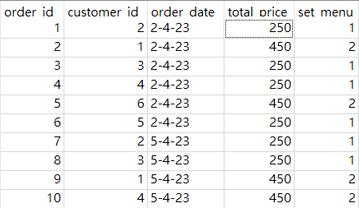

The Orders table stores the information of an order, including customer information, ordering date, the choice of set menu and the total price of the order. The primary key of the table is the order_id, which is automatically generated. The customer_id is a foreign key, referencing the Customers table. The set_menu_id is another foreign key, referencing the Set Menus table.

Order items: Order ID, item and quantity

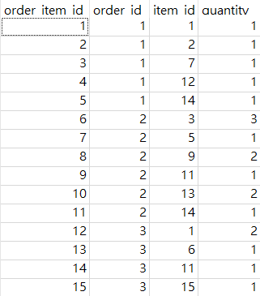

The Order Items table stores the choice of menu items corresponding to an order, including the item ordered, the quantity ordered, and the corresponding order id. The primary key is order_item_id, which is automatically generated. The order_id is a foreign key, referencing the Orders table. The item_id is another foreign key, referencing the Menu Items table.

Logical view: Order List

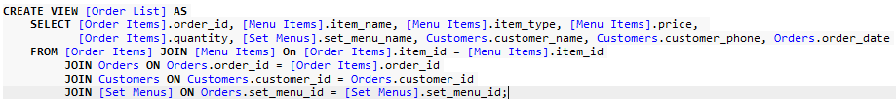

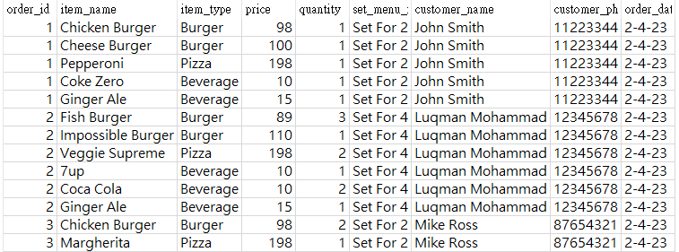

The Order List view shows all information of orders made in logical view. This view shows every ordered item with their name, type, price, quantity, and their corresponding order id, set menu, order date, and customer information.

3.3 Test results

1. List all items in 1 order

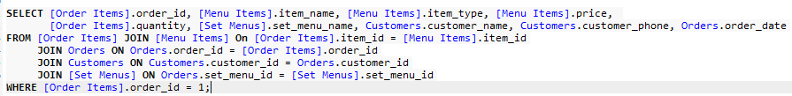

Sample results:

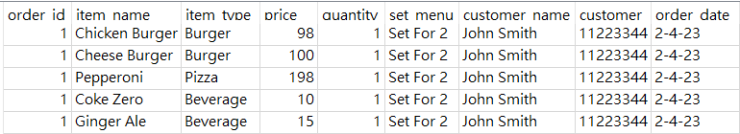

When the customers want to check the item they have ordered, or when the restaurant workers want to check a customer’s order, they can use this query to list out all items in one single order. This query shows the item name, type, price and quantity of the items in an order, and also shows the customer information and order date for user’s convenience.

1. List all items ordered in one day

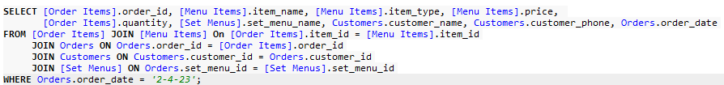

Sample results:

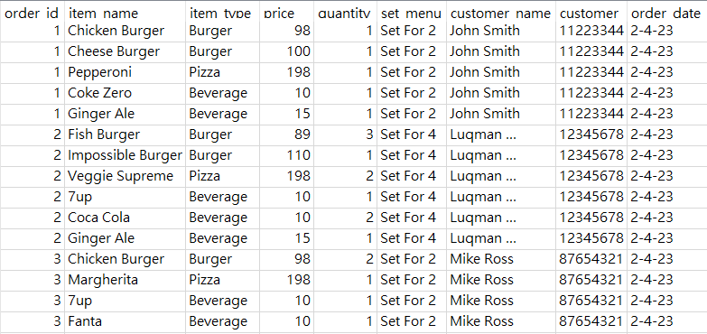

This query is made for the restaurant owner and workers to check all items ordered on a specific day. The users can use this query to help analyze the daily sales of each item, or the preferences of customers.

1. List all orders made by 1 customer

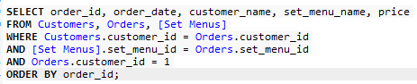

Sample results:

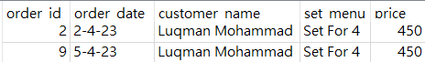

This query is made for users to check the history of orders made by a particular customer. It shows the date, customer’s name, set menu ordered, and the price of the set menu.

1. Recommendations and Conclusion

4.1 Recommendations

There is much room for improvement however this system fulfills the basic requirements of the business. Regarding the improvements, the system can be improved in multiple aspects, some being the integration of a payment gateway into the system to handle online payments, having the ability to manage single item orders and having data analytics tools to analyze customer behaviors and improve the marketing strategy accordingly.

4.2 Conclusion

In the project, we have designed a food ordering system for a small restaurant that only has the option for self designed set menus. The report highlights the background of the business, the user requirements and also some assumptions and limitations. We have also tried to show some sample test data that shows how the system works and how the data is presented to the user. The system being minimal can still cater to all the necessary user needs of the business by keeping all the information about the orders and the customers and has the ability to manage all sets and menu items with the ability to modify, add and delete menu items and customer records.